**Role of Millimeter Wave for Future 5G Mobile Networks: Its Potential, Prospects and Challenges**

**ABSTRACT:**

In order to offer a wide range of high-quality customised services, 5G mobile communications aims to have high data bandwidth, limitless networking potential for information exchange, and vast signal coverage capability to the end users. Making this 5G vision a reality guides the 3GPP-defined idea of 5G New Radio (NR), an air border architecture that will deliver new levels of elasticity, scalability, and efficiency to satisfy the growing connectivity needs in the coming age and beyond. It has established if the underutilised millimeter-wave (mm Wave) radio spectrum is appropriate for the impending 5G broadband wireless communication networks. In order to effectively place mmWaves mobile communication devices, the mmWaves propagation channel fact is fundamental.

**Keywords**—5G, Millimeter wave; 3GPP; new radio; scalability; data bandwidth

**EXISTING SYSTEM:**

We provide mmWave communication methods that take advantage of the channels' innate sparsity in the angle and latency domains. In particular, we suggest the use of fast FFT-based modulation and demodulation schemes to expose the virtual-channel coefficients, aperture shaping to ensure a sparse virtual-domain MIMO channel representation, a pilot design that enables fast LASSO-based sparsechannel estimation, and spectrally efficient precoding and decoding using the Lanczos algorithm and waterfilling over both frequency and angle. Numerical tests show that our strategy is almost capable of exploiting the mmWave channel's perfect-CSI capacity.

**DISADVANTAGES:**

* Higher costs in manufacturing of greater precision hardware due to components with smaller size
* It may result in lower sensitivity in a receiving system due to the lesser energy collected by the smaller size antenna
* At extremely high frequencies, there is significant attenuation..

**PROPOSED METHOD:**

It shows the operational range of 30-300 GHz band in mmWaves system, which is a promising result of the 5G cellular system for the future invention for backing up the multiple Gb/s of data rates. But the huddle is the handling of the channel weakening at the high frequency bands and transmission attributes. Due to higher carrier frequency the path loss is high in the propagation of mmWaves, which remains as major disablement and it reduces the existing diversity by decrease in scattering which leads to the obstruction of weak non-line-of -sight path with high outcomes. A mm-wave uplink system where one single-antenna UE transmits OFDM signals to the BS with M antennas. The BS antennas are connected to a phase shift network and $N_{RF}$ RF chains. In the digital processing unit, the signals are processed with matched filters.

As the number increases usage of higher bandwidths the noise power effect is more evident.

Path Loss: - The carrier frequency which is also denoted as ‘fc’ leads to the path loss in free space. The antenna size is reducing along with the increase of the carrier frequency. The result we obtain by this will be determined by antenna scales by a cause of λ24π, while for the case of free space path loss it grows with fc2. Therefore, the carrier frequency fc is increased from 3 to 30 GHz; irrespective of the distance between transmitter-receiver harmoniously enhance a power loss of 20dB. However for increased frequency, the prevention of the path loss from changing occurs due to a stable antenna opening at one point of the connection by growing frequency. The downfall of free path loss with fc2 will occur by maintaining the constant antenna aperture of each ends.

Blockage: - The effect of blockages on Microwave signals is less accountable be-cause of their fading property due to distraction. In addition to it, mm waves have a lesser tendency to diffract as compared to microwaves and therefore much more vulnerable to blockages. This mainly leads to the formation of a bimodal channel due to absence of line of sight. Recent literature survey has revealed that in paper studies has been conducted to study the dependency of path loss on transmitter and receiver distance. It has been found out that the path loss decreases at a rate of 20 dB/decade under standard line of sight transmission. The path loss for the non-line of sight link further decreases to 40 dB/decade with 15-20 dB additional loss. It can be thus concluded that shifting of the connection system from usable non-usable version according to blockages. Hence small scale remedies cannot evade substantial shortcomings as concluded in.

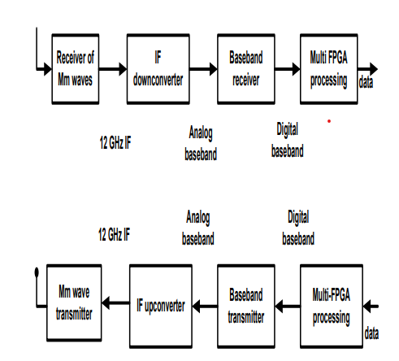

Fig. mm waves Transceiver design

**Advantages:**

1. mmWaves bundled along with couple of symbiotic techniques such as massive MIMO and femto cells are sufficient in attaining an ideal tough system
2. Pairing 5G with mmWave provides massive capacity and even lower latency to unlock the full 5G experience.
3. To achieve even higher frequency, longstanding mmWave technology can be utilized for next generation connectivity.

**Applications:**

1. WiGig technology

2. Satellite Communication,

3. Automotive Applications,

4. HD video applications.

**Software & Hardware Requirements:**

**Software:** Matlab R2018a.

**Hardware:**

**Operating Systems:**

• Windows 10

• Windows 7 Service Pack 1

• Windows Server 2019

• Windows Server 2016

**Processors:**

Minimum: Any Intel or AMD x86-64 processor

Recommended: Any Intel or AMD x86-64 processor with four logical cores and AVX2 instruction set support

**Disk:**

Minimum: 2.9 GB of HDD space for MATLAB only, 5-8 GB for a typical installation

Recommended: An SSD is recommended a full installation of all Math Works products may take up to 29 GB of disk space

**RAM:**

Minimum: 4 GB

Recommended: 8